MPCA: Lab - 6

Name: Rithvik Rajesh Matta
SRN: PES2UG23CS485
Sec: H

- #include <stdio.h>

int main() {
int x = 10, y = 5;
if (x > y)
printf(“x is greater\n”);
else
printf(“y is greater\n”);
return 0;
}
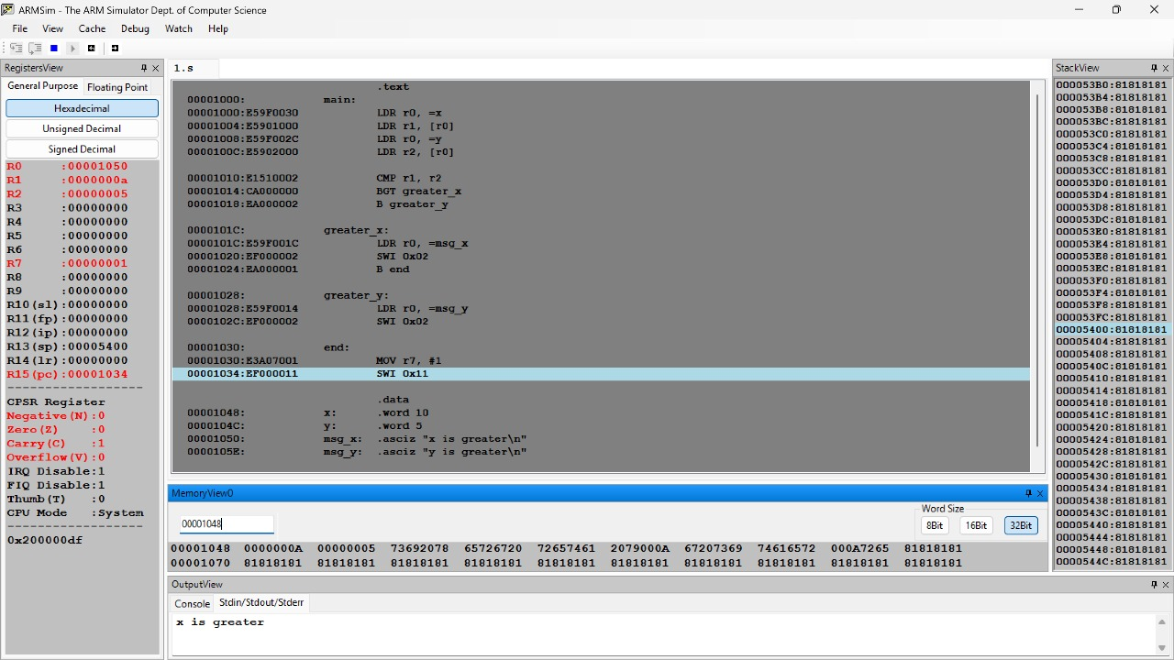

- #include <stdio.h>

int add(int a, int b) {
return a + b;
}

int main() {
int result = add(5, 3);
printf("Sum: %d\n", result);
return 0;
}

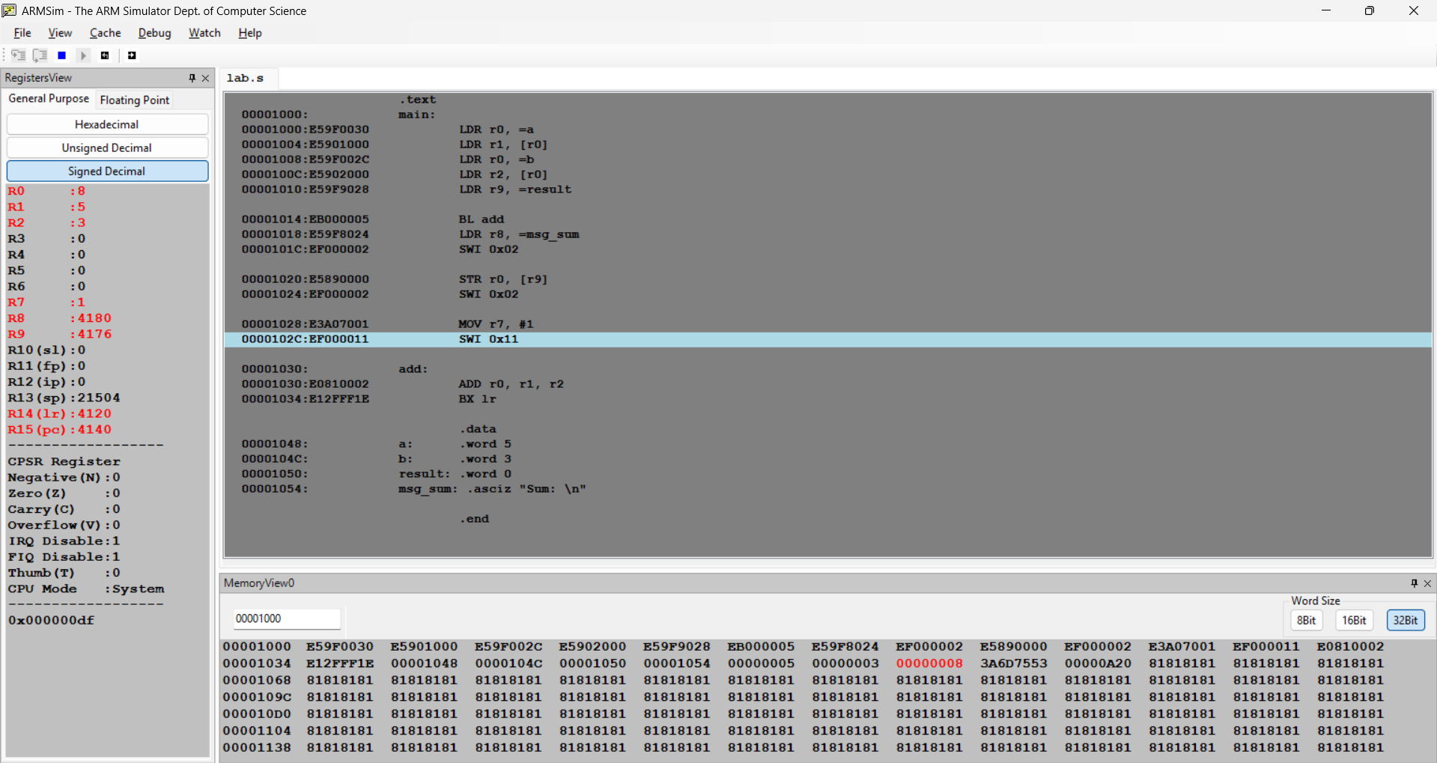

- #include <stdio.h>

int main() {
int num = 2;
switch (num) {
case 1:
printf("One\n");
break;
case 2:
printf("Two\n");
break;
case 3:
printf("Three\n");
break;
default:
printf("Invalid\n");
}
return 0;
}

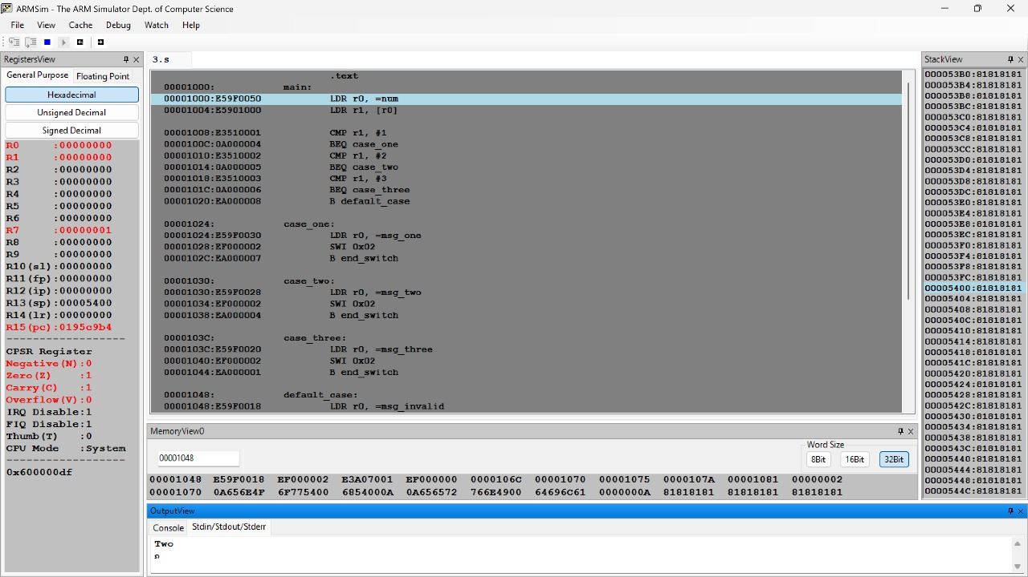

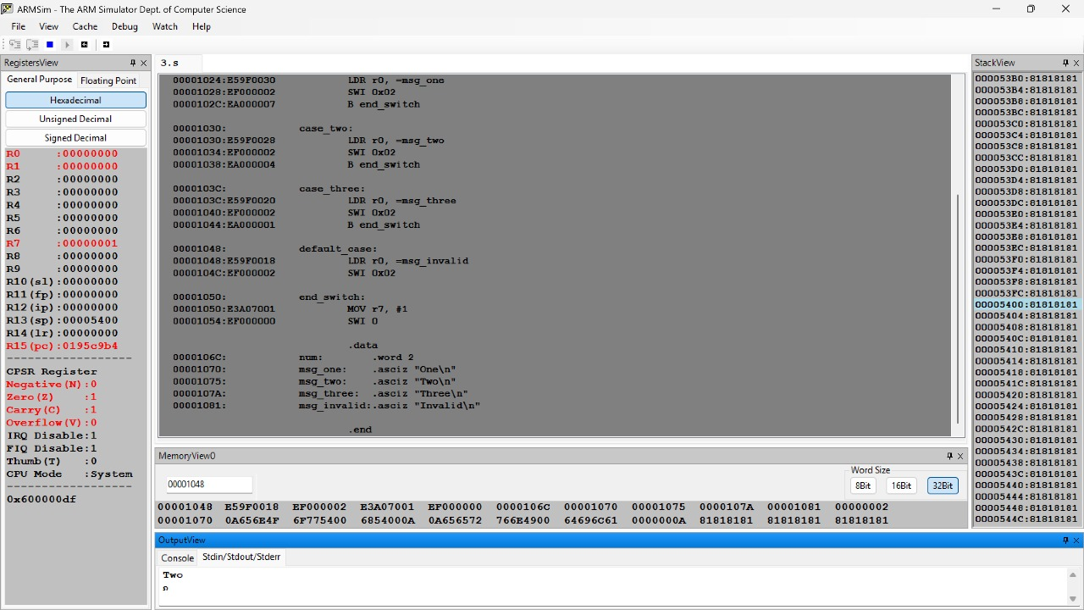

- #include <stdio.h>

int main() {
int x = 5, y = 3;
int and_op = x & y;
int or_op = x | y;
int xor_op = x ^ y;
printf("AND: %d, OR: %d, XOR: %d\n", and_op, or_op, xor_op);
return 0;
}

